**NAME: Aarya Tiwari**

**ROLL NO:16010421119**

**BATCH:A3**

**EXPERIMENT: 2**

**COURSE: CC Laboratory**

**DATASET:**

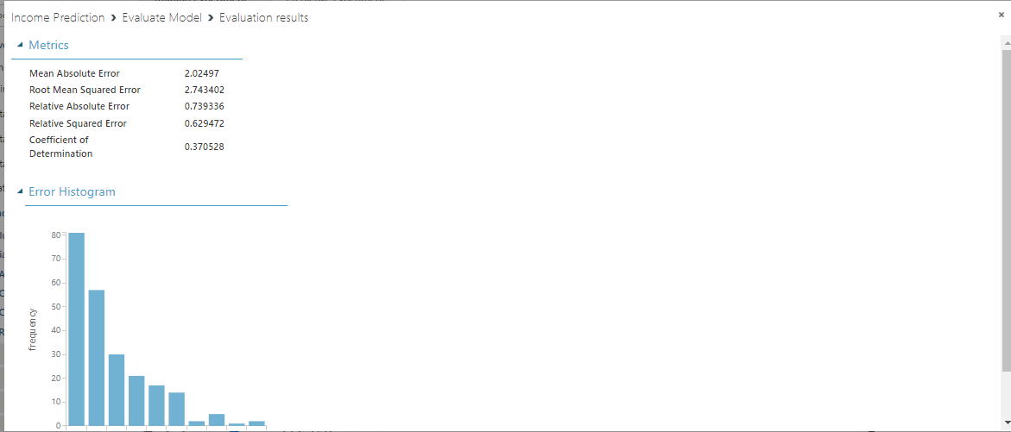

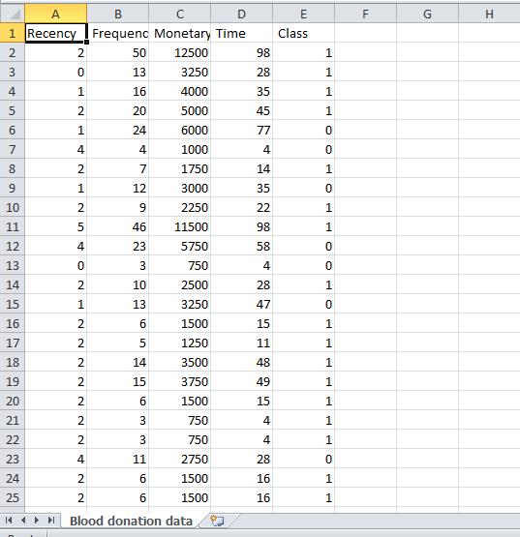

**MODEL:**

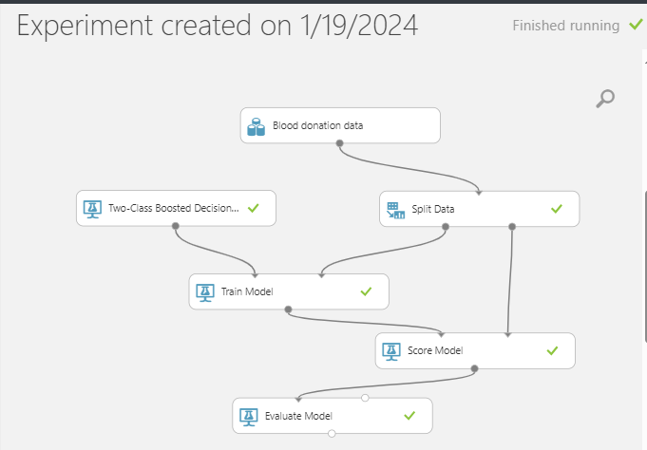

**EVALUATION:**

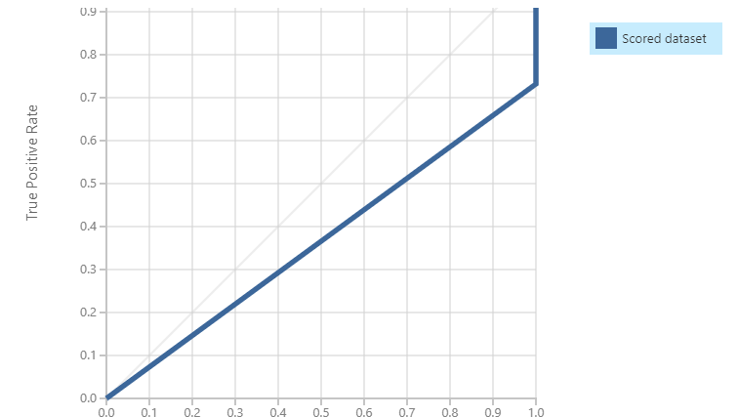 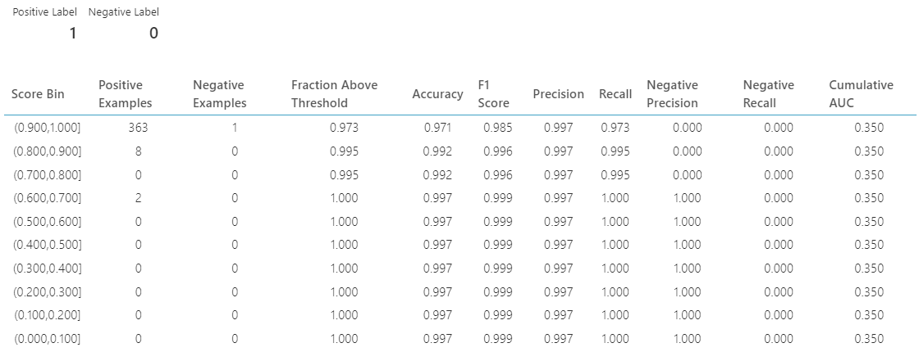

**Q1) Problem faced by the business:**

1) High Diabetes Rates: The Pima Indians have historically faced high rates of diabetes. Managing and preventing diabetes within the community can be a significant challenge, requiring healthcare resources, education, and lifestyle changes.

2) Healthcare Access: Access to quality healthcare can be a challenge in some indigenous communities. Limited healthcare infrastructure, distance from medical facilities, and economic factors can impact individuals' ability to receive proper care and management for diabetes.

3) Economic Challenges: Indigenous communities often face economic challenges. Establishing and sustaining businesses, including those focused on healthcare or diabetes management may be hindered by limited resources, funding, and access to markets.

4) Cultural Sensitivity: Developing and implementing effective healthcare and business strategies must consider the cultural context of the Pima Indian community. Ensuring that programs and businesses are culturally sensitive and respectful is crucial for success.

5) Education and Awareness: There may be a need for increased education and awareness within the Pima Indian community regarding diabetes prevention, management, and the importance of a healthy lifestyle. Lack of awareness can contribute to the high prevalence of the disease

**Q2) Approach/ Methodology followed by the business:**

1. **Needs Assessment:**

Conduct a thorough needs assessment within the Pima Indian community to understand the specific challenges related to diabetes. Identify gaps in healthcare services, educational resources, and economic opportunities related to diabetes management.

1. **Community Engagement:**

Establish strong communication channels with the Pima Indian community leaders, healthcare professionals, and members.

Hold community forums, meetings, or surveys to gather input, feedback, and insights into the community's preferences, cultural considerations, and specific needs regarding diabetes.

1. **Cultural Sensitivity and Competence:**

Develop a culturally sensitive approach to diabetes management and healthcare. Ensure that programs and services respect and integrate the cultural values and traditions of the Pima Indian community.

1. **Healthcare Services**:

If the business involves healthcare services, collaborate with healthcare professionals to provide regular check-ups, screenings, and educational programs.Facilitate access to affordable and culturally competent healthcare resources for diabetes prevention, treatment, and management.

1. **Education and Awareness:**

Implement educational initiatives to raise awareness about diabetes, its risk factors, and preventive measures. Provide educational materials in a culturally appropriate manner, considering the language and literacy levels of the community.

**Q3) Skillsets, infrastructure and other impact on the business during implementation:**

1. **Skillsets:**

Healthcare Professionals: Having healthcare professionals with expertise in diabetes management, nutrition, and preventive care is crucial. This includes doctors, nurses, dieticians, and other specialists.

Cultural Competence: Individuals with an understanding of the Pima Indian culture and traditions are essential for effective communication and engagement with the community.

Community Outreach and Education: Skilled professionals who can design and implement educational programs tailored to the community's needs, including workshops, seminars, and awareness campaigns.

1. **Infrastructure:**

Healthcare Facilities: Depending on the nature of the business, infrastructure may include clinics or health centers equipped to provide diabetes screenings, consultations, and follow-up care.

Information Technology: Implementing systems for data management, electronic health records, and telehealth services, if applicable, to enhance the efficiency and effectiveness of healthcare delivery.

Community Centers: Establishing or utilizing existing community spaces for education, workshops, and support group activities related to diabetes management.

Technological Tools:

Telemedicine Platforms: Implementing telehealth solutions can enhance accessibility to healthcare services, especially for those in remote areas.

Health Information Systems: Utilizing technology for health data management and monitoring, which can aid in tracking health outcomes and program effectiveness.

1. **Human Resources:**

Community Health Workers: Employing individuals from within the community as health educators or community health workers can strengthen the trust and effectiveness of healthcare interventions.

Business Management: Skilled individuals in business management to oversee the financial and operational aspects of the business.

1. **Economic Impact:**

Job Creation: The business can have a positive impact on the local economy by creating job opportunities within the community, especially if it involves healthcare services or related industries.

Training Programs: Offering training programs to community members, enhancing their skills and employability in healthcare or related fields.

**Q4) Similar approaches followed by other businesses**

**Community-Centered Care:**

Prioritizing community input and involvement in the planning and decision-making processes.

Implementing culturally competent healthcare services that consider the community's values, traditions, and preferences.

**Preventive Healthcare Programs:**

Offering preventive care services, including screenings, educational programs, and lifestyle interventions to reduce the risk of chronic diseases.

**Education and Awareness:**

Developing and implementing comprehensive health education and awareness campaigns.

Utilizing various mediums such as workshops, seminars, community events, and digital platforms to disseminate information.

**Technology Integration:**

Leveraging technology for telehealth services, health monitoring, and data management.

Implementing electronic health records (EHRs) to streamline patient information and improve healthcare delivery.

**Community Health Workers:**

Employing community health workers or lay health educators to bridge cultural and linguistic gaps between healthcare providers and community members.

Offering training programs to community members to enhance their role in health promotion.

**Q5) Follow Machine learning studio for developing an application:**

1. **Define the Problem and Objectives:**

Clearly define the problem you want to solve and the objectives of your machine learning application. This could be anything from predictive analytics to image recognition.

**2. Gather Data:**

Collect and preprocess relevant data for your machine learning model. Ensure that the data is cleaned, labeled, and properly formatted. The quality of your data significantly influences the performance of your machine learning model.

**3. Choose a Machine Learning Studio:**

Several machine learning platforms and frameworks are available. Popular ones include:

TensorFlow:

Developed by Google, TensorFlow is an open-source machine learning library widely used for various applications, including deep learning.

PyTorch:

Developed by Facebook, PyTorch is another popular open-source deep learning library known for its flexibility and dynamic computation graph.

Scikit-Learn:

A simple and efficient tool for data mining and data analysis, scikit-learn is built on NumPy, SciPy, and Matplotlib.

Azure Machine Learning Studio:

Microsoft's Azure ML Studio provides a cloud-based environment for developing, testing, and deploying machine learning models.

AWS SageMaker:

Amazon SageMaker is a fully managed service that enables you to quickly build, train, and deploy machine learning models at scale.

4. Develop and Train the Model:

Use the chosen machine learning studio to develop and train your model. This involves selecting an appropriate algorithm, splitting your data into training and testing sets, and fine-tuning the model parameters.

5. Evaluate the Model:

Assess the performance of your machine learning model using appropriate metrics. Common metrics include accuracy, precision, recall, and F1-score, depending on the nature of your problem.

**COCLUSION: Learnt about the case study and implementation of Big Data analytics using Microsoft Azure (PaaS)**

**CO2: Study the Evolution of Cloud Computing and its models**